**CST-341 Design Report**

|  |  |  |
| --- | --- | --- |
| **Topic:** | Configuring the List Application by Adding a Maven Config. File as well as Packing the Application using Maven. | |
| **Date:** | June 17 2018 | |
| **Revision:** | Version 7.0 | |
| **Team:** | 1. Roman Parkhomenko | |
| 1. Gary Sundquist | |
| 1. Fredrick Ondieki | |
|  | |
| **Weekly Team Status Summary:** | |  |  |  |  | | --- | --- | --- | --- | | **User Story** | **Team**  **Member** | **Hours**  **Worked** | **Hours Remaining** | | Fixed issue with getting username session information for the list page. We are now passing the username once a user logs in onto the list page. | Gary Sundquist |  |  | | Added calendar feature to the list page | Roman Parkhomenko |  |  | | Troubleshot issues he was having with database connectivity | Fredrick Ondieki |  |  | |  |  |  |  | |  |  |  |  | |  |  |  |  | |  |  |  |  | |  |  |  |  | |  |  |  |  | |  |  |  |  | |  |  |  |  | |  |  |  |  | |  |  |  |  | | |
| **GIT URL:** | https://github.com/Ninjaroz/CST341.git | |
| **Peer Review:** | *Y/N* | Yes. We acknowledge that our team has reviewed this report and we agree to the approach we are all taking. |

***Planning* Documentation**

**Agile Scrum Product Backlog:**

https://github.com/Ninjaroz/CST341.git

**Agile Scrum Sprint Backlog:**

*https://github.com/Ninjaroz/CST341.git*

**Agile Retrospective Results:**

|  |
| --- |
| **What Went Well** |
| Calendar is up and running and updating the date that the list page shows. |
| Fixed session issue with the username not being passed to the list page. |

|  |  |  |
| --- | --- | --- |
| **What Did Not Go Well** | **Action Plan** | **Due Date** |
| Team is still having issues with database connectivity. | Team needs to add their connection details to the servlet-context.xml file and comment out other team members data source. |  |
| Team was unable to finish list page. | We still need to change a few methods to use the username passed to the list page as well as the date generated by the calendar to generate lists. We also need the list page to prepopulate itself using the credentials of the user currently signed in and the current date. |  |
|  |  |  |
|  |  |  |

**Project structure**

**The structure of the project is shown on the pictorial diagram.**

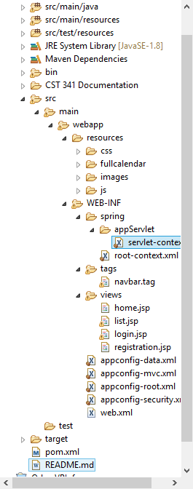 **Design Documentation**

**Install Instructions:**

Used the MySQL Workbench as the relational database to store the user activities, list of priorities for the day as well as the username and password. However, for the List Application to communicate we needed to add dependencies to support such connection. Therefore, we added the mysqlconnector.jar file. Also, on the server aspect, we used the Apache Tomcat version 9.0. Using the Intellij IDEA (No much difference from Eclipse IDEA), we used the following approach to add the project facets to the server for successful deployment.

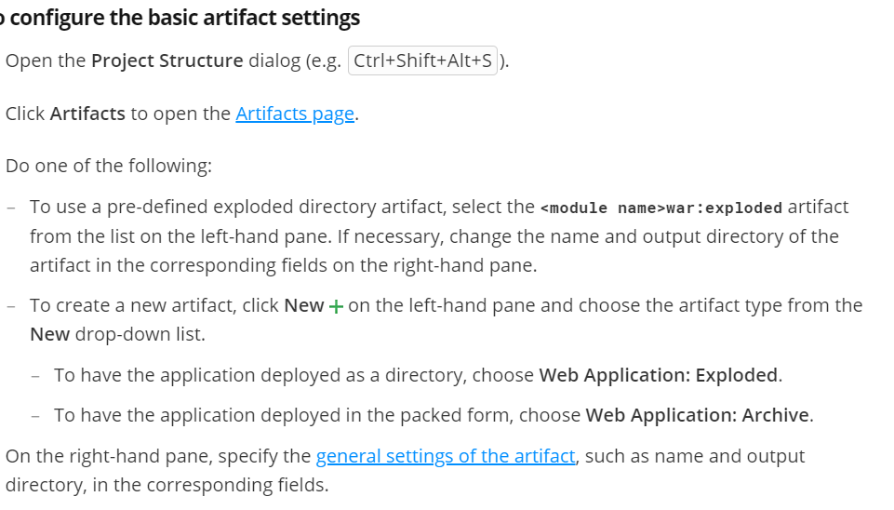

**General Technical Approach:**

It is through a string of text messages and group forums that we were able to communicate and ensured that our project was completed successfully. As described on our design documentation version 1.0, we are still expounding on the flow of the application only adding and improving features such as keeping sessions when the user logs in to the application.

**Key Technical Design Decisions:**

Used the following technologies in creating the application

**Apache Tomcat** Server version 9.0.8- Server

**Spring Hibernate**- connects with the database itself and uses HQL (Hibernate Query Language) to execute the queries, then maps the results to Java objects.

**MySQL Workbench**- Database.

**Bootstrap**- Create a responsive web pages due to its speed of development. Also, it is easy to use and integrate in an application.

**Jquery**- Easy to Integrate

**Eclipse IDE** and **IntelliJ IDEA**- Development environments.

**Known Issues:**

The issues experienced was connecting to the database as shown on the following screenshot.

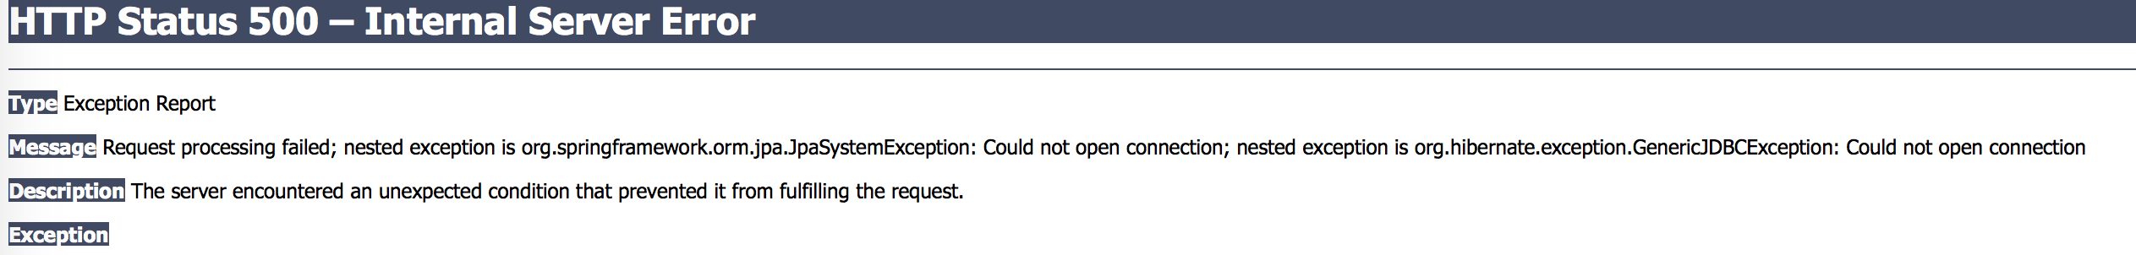

**Risks:**

We are tracking down the issue of database connectivity and thus we will be able to handle the hibernate exception. We will try and follow the directions outlined on the screenshot shown below.

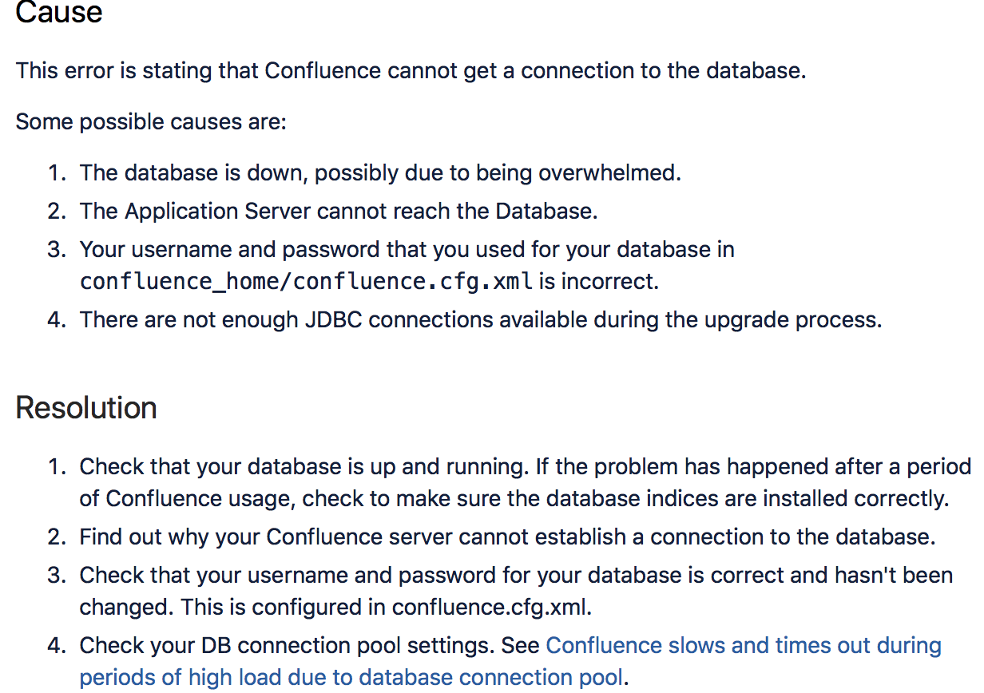

**ER Diagram:**

The diagram bellow shows successful connection of the database (accounts) with the tables.

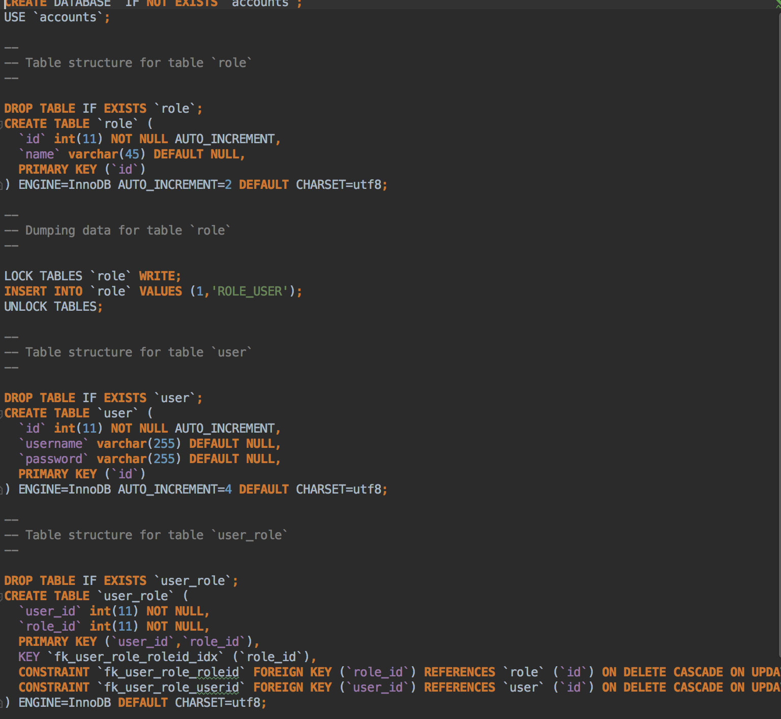

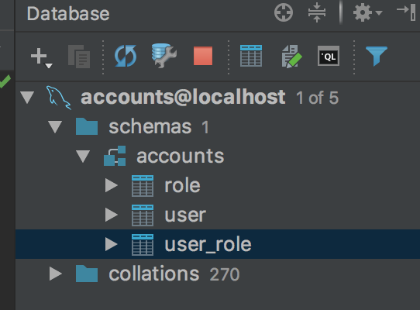

**User Interface Diagrams:**

**The screenshots bellow describes further the flow of the program.** 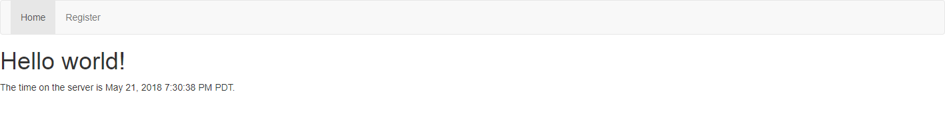

Successful login in to the application brings the above homepage.

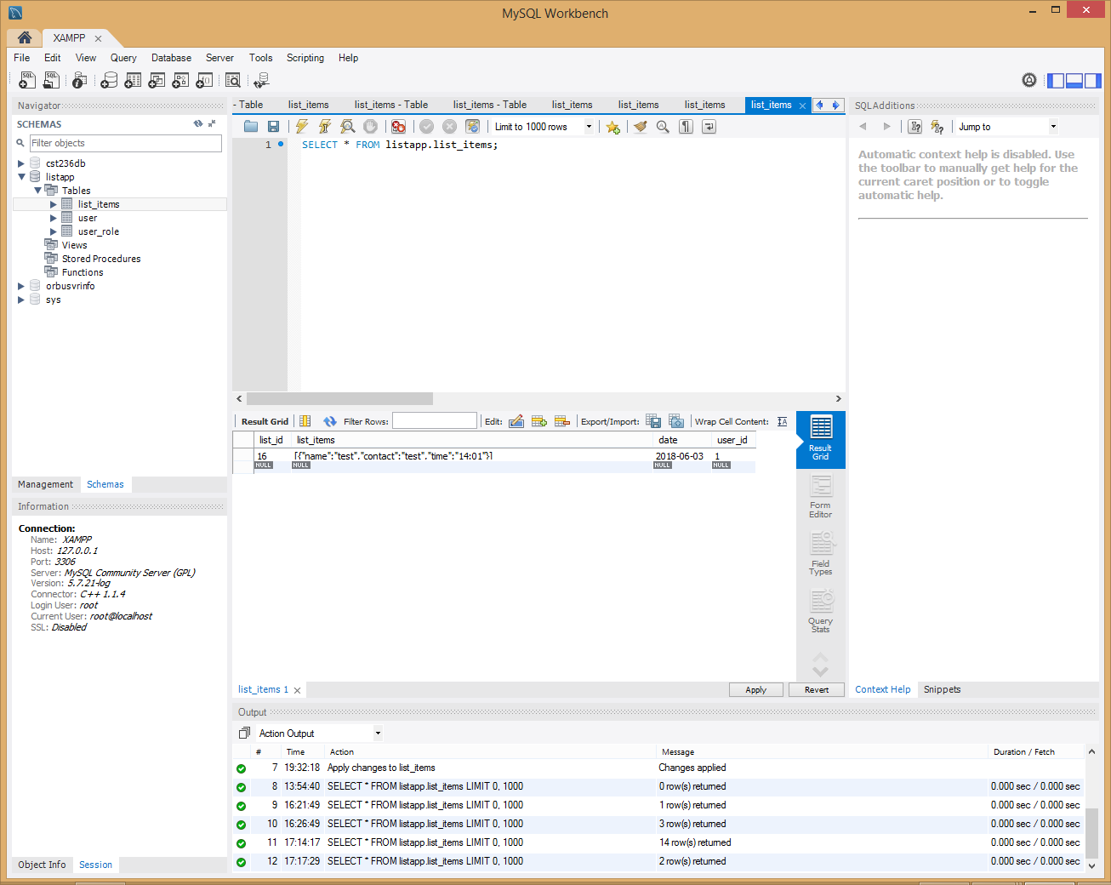

Database being updated successfully.

Current logged in user is now being successfully passed to the page and the calendar is working and updating the date.

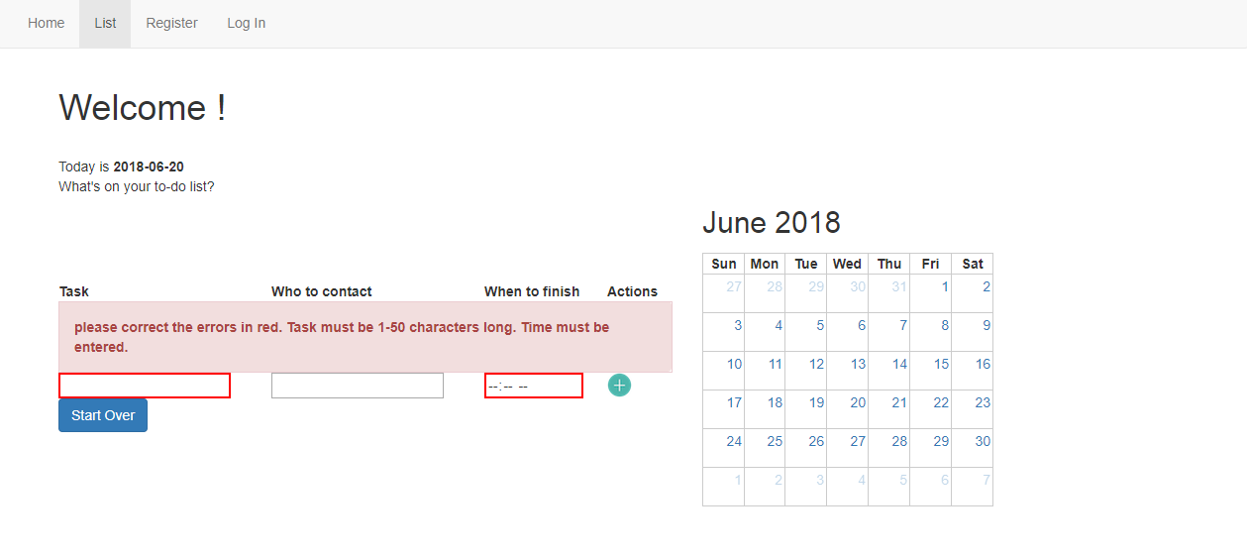

**Class Diagrams:**

All the class diagrams as well as the code is uploaded to the Git hub repository account accessed via the link

https://github.com/Ninjaroz/CST341.git